**WeatherPy**

**Analysis:**

1. **City Latitude v/s Cloudiness**

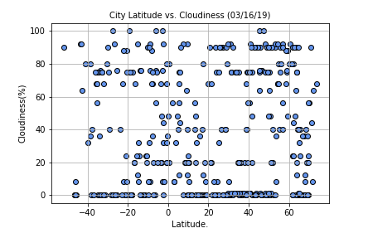

As suggested earlier there is no correlation between Latitude and cloudiness, but majority of cities has 0 to 90 % cloudiness.

1. **City Latitude v/s Max Temperature**

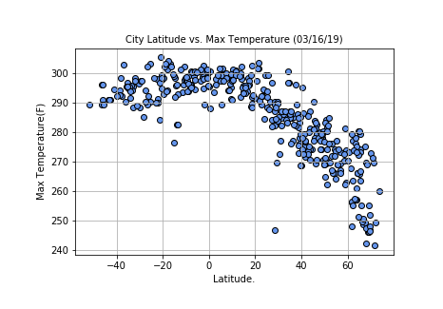

We can see higher temperatures are around the equator between -20 to 20 deg F, this proves that the temperatures are no exactly at 0 deg F but around it.

1. **City latitude v/s Humidity**

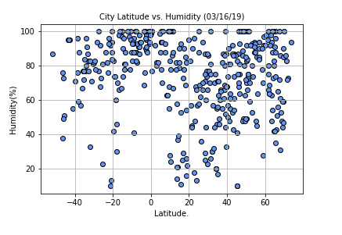

We can see there is no correlation between latitude and Humidity, but majority of the cities have humidity % are between 60 to 100%.

1. **City Latitude vs Windspeed**

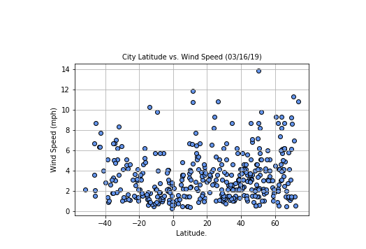

Based on the above graph I feel majority of cities between 0 to 6 mph.